* 7Power Constraints
  + Seems to work

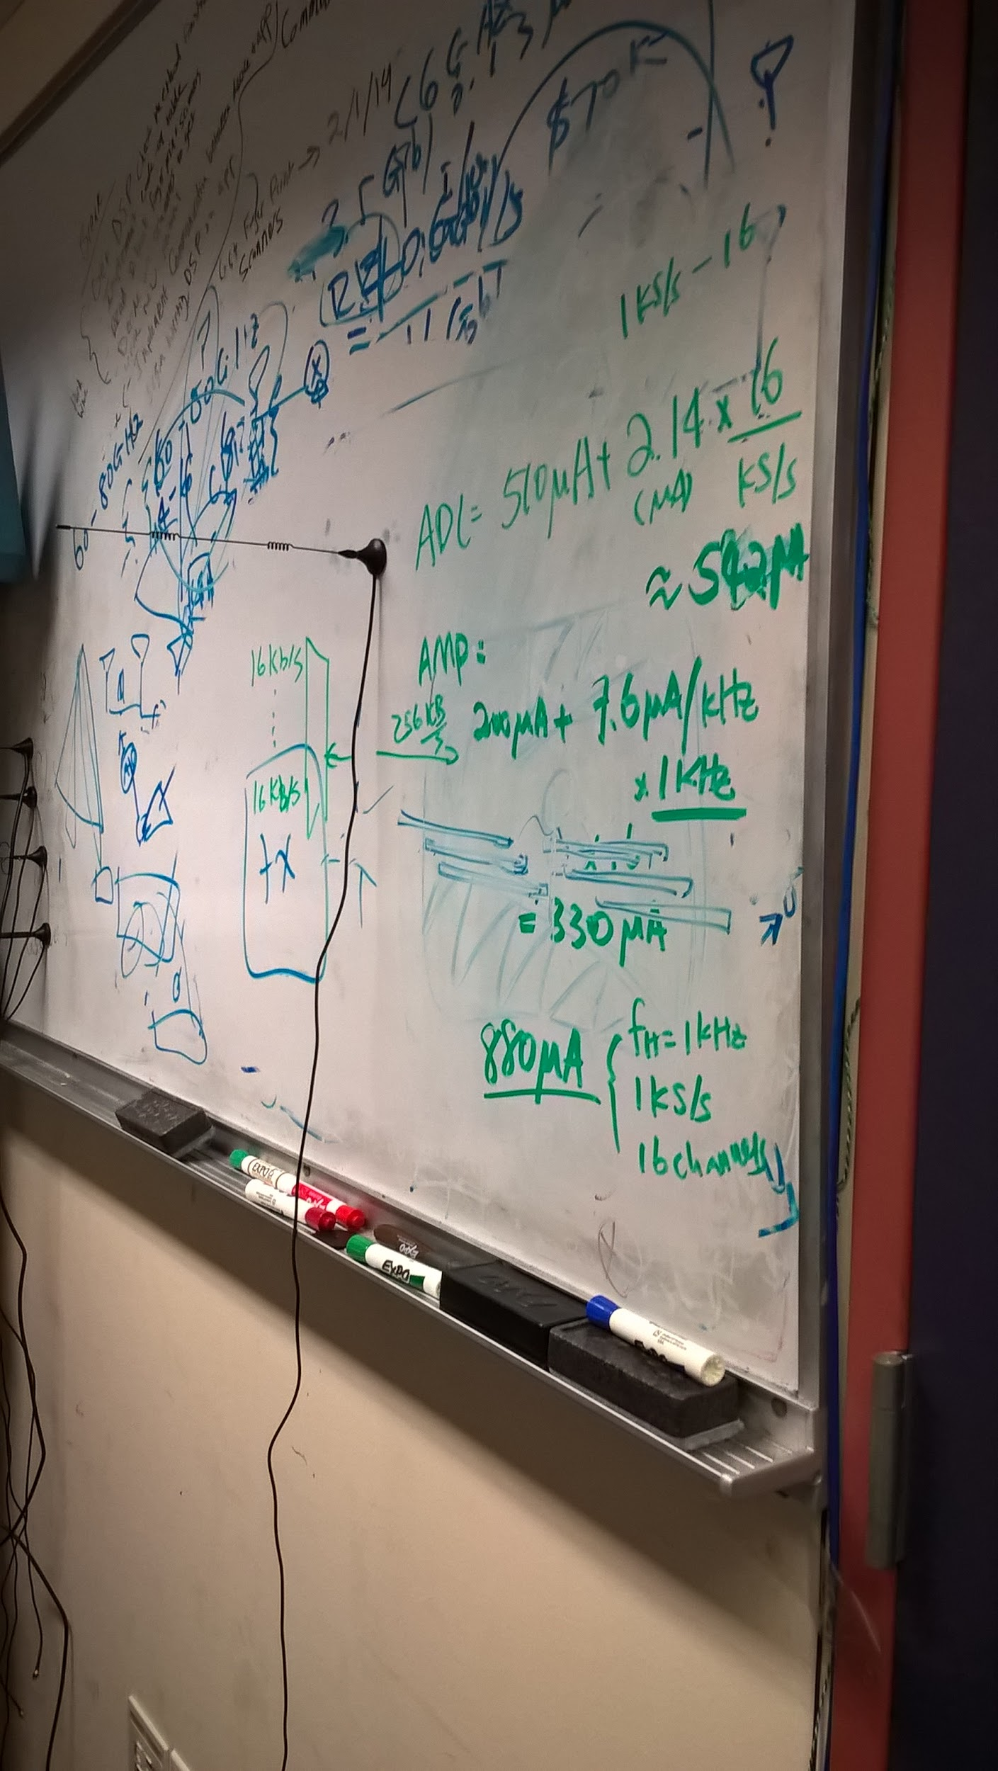

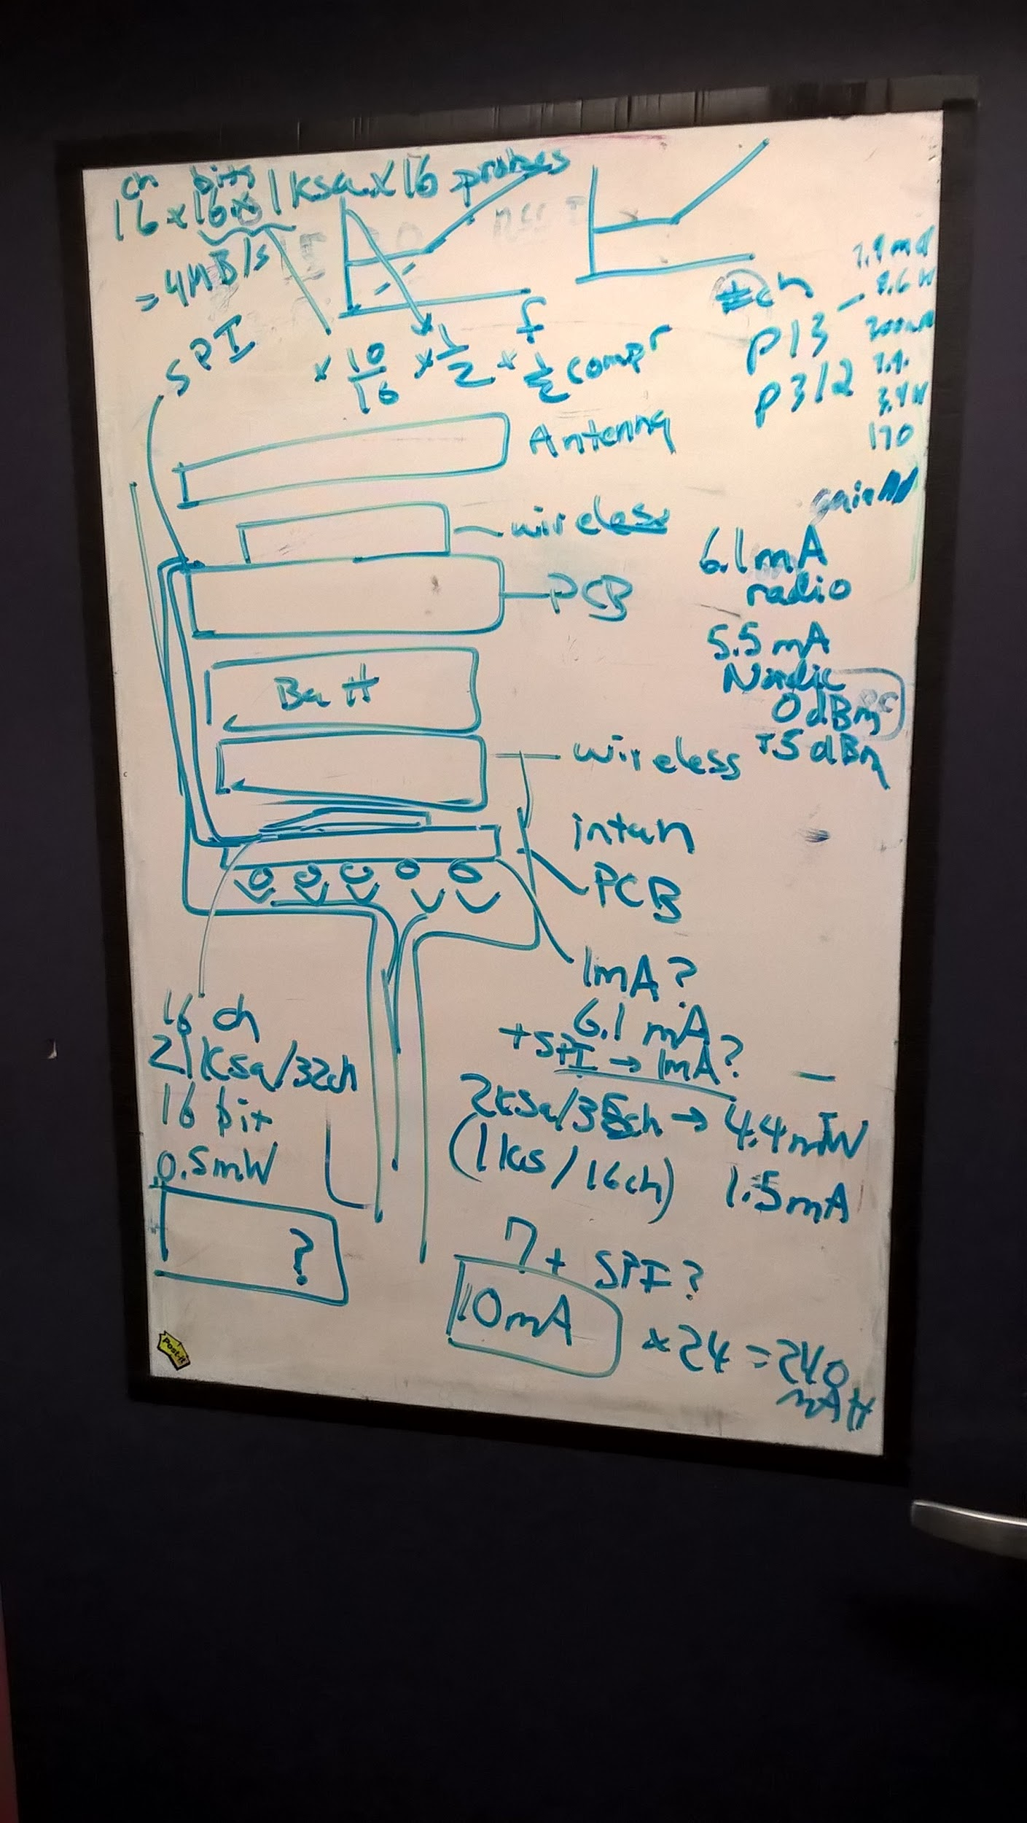

* Compression
  + See how much we can decimate by
* For next time:
  + report the feasibility
  + CYCLE ONE documentation